**E9 241: Digital Image Processing - Assignment 02 Report**

Name: Kartikeyan Iyer

SRN: 04-03-01-10-42-25-1-25922

**1. Spatial Filtering and Binarisation**

In this section, a box blur was applied to the image *'moon_noisy.png'* with varying filter sizes, followed by Otsu's binarization.

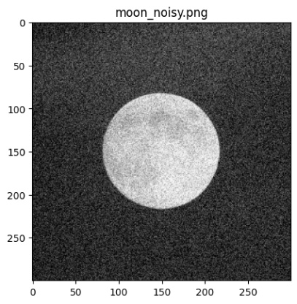

**Original Image**

**Results for Varying Filter Sizes**

The following are the results for filter sizes *m* = 5, 29, and 129.

**Analysis and Inferences**

The optimal filter size that minimizes the within-class variance was found to be **m = 176.676**3

* **Effect of Blurring**: As the filter size *m* increases, the degree of blurring becomes more significant. This smoothing effect merges the noise with the foreground and background, which is reflected in the histograms.
* **Histogram Changes**: For a small filter size (m=5), the histogram of the noisy image likely still shows a less distinct separation between modes. As *m* increases, the Box blur averages out the noise, causing the two peaks corresponding to the moon and the background to become more distinct and narrower, leading to a deeper valley between them.
* **Optimal Variance**: Otsu's method works best when the histogram is clearly bimodal. A moderate amount of blurring (like m=29) is expected to produce the best separation, thus minimizing the within-class variance. An excessively large filter (m=129) might blur the edges of the moon too much, causing the modes to merge again and increasing the variance.

**2. Scaling and Rotation with Interpolation**

This section explores the effect of the order of operations—specifically upsampling and rotation—on the final image quality.

**Results**

**Operation 1: Upsample First, then Rotate**

The original 'flowers.png' image was first upsampled by a factor of 2 and then rotated by 45°.

**Operation 2: Rotate First, then Upsample**

The original 'flowers.png' image was first rotated by 45° and then upsampled by a factor of 2.

**Difference Image**

The difference between the two results (Result 1 - Result 2) was computed and is shown below.

**Analysis and Inferences**

* **Range of Difference Values**: The minimum and maximum values of the difference image were found to be **-31.8815** and **113.8857,** respectively.
* **Visual Analysis**: When plotted, the difference image highlights the edges and fine-textured areas of the flowers and grass. This indicates that the primary differences between the two methods occur in regions of high detail.
* **Discussion on Differences**: The two results are **not identical**. The haziness in the "Rotate First, then Upsample" image demonstrates that the order of operations matters significantly.
  + **Upsample First (Clearer Result)**: Upsampling the image first creates a high-resolution canvas. The subsequent rotation has more pixel information to work with during its interpolation step, which preserves details and edges more effectively.
  + **Rotate First (Hazy Result)**: Rotating the low-resolution image first introduces interpolation artifacts and blurring. When this already-degraded image is upsampled, these artifacts and the blurriness are magnified, resulting in a less sharp final image. This is why it appears hazy.

**3. Image Sharpening Concept**

A function ***sharpenAdjust(img, p)*** was designed to control image sharpness based on the principles of unsharp masking.

study.png

**Methodology**

The sharpening effect was achieved using the following formula, which is a variation of the unsharp mask:

***Sharpened Image = Original Image + p * (Original Image - Blurred Image)***

Here, (Original Image - Blurred Image) creates a high-pass filter that isolates the details. The parameter p controls how much of this detail is added back to the original.

**Results on 'study.png'**

The function was tested on 'study.png' with different values of p.

**Analysis and Inferences**

* **p = 0**: The output is identical to the input, as the detail mask is multiplied by zero.
* **0 < p < 1**: As p increases, the edges and textures in the image become more pronounced. The sharpening effect is noticeable but generally appears natural.
* **p = 1**: Strong sharpening is applied. This results in a very crisp image, but it also introduces artifacts known as "halos" along high-contrast edges. These are the bright and dark outlines visible around objects, which occur due to the over-emphasis of the detail mask.